 Sasol Limited (JSE: SOL)

Current Price: ZAR 82.17 | Target Price: | Sector: Oil and Gas
Recommendation: BUY

- Figure 1:Company Data  Source: S&P Capital IQ | - EXECUTIVE SUMMARY  We initiate coverage on Sasol Limited (JSE: SOL) with a Buy Recommendation based on a 12-month target price of R278.00 based on a blend of DCF valuation and relative multiples. Sasol trades at a significant discount to fair value, with improving fundamentals, margin expansion, and deleveraging efforts expected to drive investor re-rating.  Sasol Limited is a South African integrated energy and chemical company with operations spanning the extraction and processing of oil, gas, and coal, as well as the production of value-added chemicals. Amid a volatile energy environment and regulatory transitions, Sasol is in the midst of a multiyear transformation to a lower-carbon, more capital-efficient business model.
  Last Close | R82.17
  Market Cap | R5.207996 Billion
  Shares Outstanding | 635419769
  52 Week High | R150.50
  52 Week low | R53.01

Business overview
  - Corporate Profile and Historical Background
- 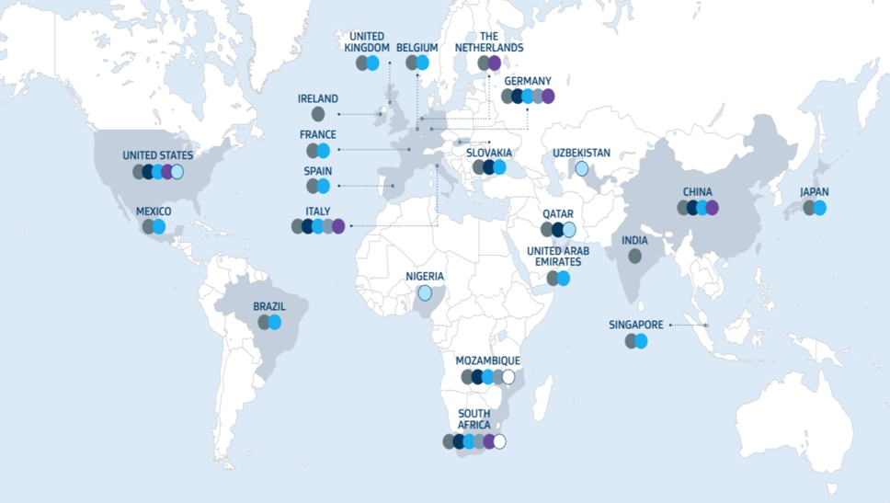 | Sasol Limited is a South African based global integrated chemicals and energy company, listed on both the Johannesburg Stock Exchange (JSE: SOL) and the New York Stock Exchange (NYSE: SSL). The company was established in 1950 through a South African government initiative to commercialise coal to liquids (CTL) technology, and has since evolved into one of the world’s leading producers of synthetic fuels and chemical products. Today, Sasol operates across 22 countries, serving over 7,000 customers in 118 nations through a vertically integrated model. This
means that the company handles most of its production stages on its own instead of relying on suppliers or outsourcing, Sasol does this by sourcing its own feedstock which is raw materials like coal and natural gas from their own mines and gas fields. The collected raw materials are then turned into a variety of products and this is all done within Sasol’s own facilities. The company’s core operations are cantered in South Africa, where it all started, It has 2 flagship complexes situated in South Africa this being the Sasolburg and Secunda complexes. These locations leverage the usage of Fischer-Tropsch (FT) synthesis to convert coal and gas feedstocks into liquid fuels and chemicals. The operations are not only limited in Africa as it has significant manufacturing assets in North America and Gas To Liquid (GTL) operations in Qatar. The collaboration in Qatar was able to be achieved through a joint venture with QatarEnergy and this was named the ORYX GTL. From 2024 the company has increased its employment numbers to 32000 global employees and have also launched the Sasol 2.0 Transformation Strategy. These are all recovery responses to the financial distress that was caused by the oil price crash during the Covid-19 pandemic. The 2.0 transformation strategy is in its final stages and will be coming to an end soon but implementation has delivered R16 Billion in EBITDA improvements, a reduced net debt and has also introduced the shift toward low carbon solutions such as renewable energy and sustainable aviation fuel (SAF). The shit to low carbon solutions is a transition that the company calls “Future Sasol” and the goal is to reduce carbon emission as Sasol is one of South Africa’s largest carbon emitters. The company aims to have reduced their Scope 1 and Scope 2 emissions by 30% by 2030.
  - Business Segment Overview and Revenue Composition
Sasol operates through an integrated value chain built around three primary business segments these being , Energy, Chemicals and Mining. These segments are all interconnected and are supported by the feedstock of internally sourced coal and gas. The structure set up allows Sasol to capture margins and profits across the entire production lifecycle, from the resource extraction to the sale of refined products.
Energy Segment
The Energy side of the business is Sasol’s largest revenue contributor and includes the production and marketing of liquid fuels, pipeline gas, electricity as well as crude oil. The production of fuel is possible because of the Coal to Liquids (CTL) and the Gas to Liquids (GTL) technologies that Sasol has developed through their Secunda and Sasolburg facilities. The company also has equity in the Natref refinery and this refinery processes imported crude oil into fuel products.  As of 2024 the sales of liquid fuel has declined by 4% year on year, this is due to the ongoing diesel market constraints going on in South Africa. The retail and commercial channel growth however have covered the decline and supported margins. | Sasol Energy Business Performance  Energy-47%  Source : Sasol. (2024). Integrated Report for the year ended 30 June 2024
Chemicals Segment
Sasol’s chemical business focus spans over four divisions. These being Base chemicals, Essential Care chemicals, Performance Solutions and Advanced Materials. The company has a rich geography in the sense that they have major chemical assets in North America, Europe and South Africa. The chemicals segment supplies a wide variety of industries such as automative, packaging, agriculture and consumer goods. Despite a decrease in chemical prices and demand, Sasol’s chemical segment has improved performance in the second half of the 2024 financial year through product sales. | Sasol Chemical Business Performance  Chemical – 53%  Source : Sasol. (2024). Integrated Report for the year ended 30 June 2024
  - Key Revenue Drivers and Geographic Exposure
Sasol generates its primary revenue from mainly 4 macroeconomic drivers. Brent Crude Oil prices, the ZAR/USD exchange rate, global chemical prices and domestic energy demand.  Brent Crude Oil Price  This driver directly impacts Sasol’s fuel business via the pricing of synthetic fuel, diesel and jet fuel products. Despite hedging instruments, the company still remains sensitive to global oil price movements. The price of Brent crude oil has declined from 2023 to 2024 by 3%, averaging $84.70/bbl. This pricing has placed downward pressure on refining margins.  Exchange Rate Volatility  Operating in the global space introduces currency risk, in the sense that the ZAR/USD exchange rates affects the conversion of dollar based sales from America and Europe into Rand. As the value of sales fluctuates so does the valuation of Sasol’s denominated debt. Looking at the 2024 financial year the Rand depreciated by approximately 5% due to the local macro-economic uncertainty and this translates to the international debt of Sasol increasing and the value of the sales increasing once currencies are converted. | Average Brent Crude Oil Price  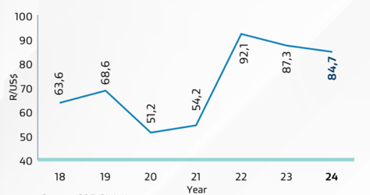 Source: S&P Global  Average Exchange Rate ZAR/US  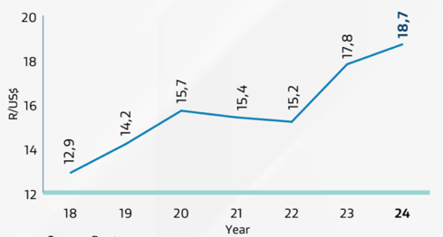  Source: Reuters

  - Strategic Transformation : The Sasol 2.0 Initiative
Objectives  -Cost Optimisation  -Asset Divestment  -Balance Sheet Repair  -Low Carbon Growth | The Covid-19 pandemic needed companies to adapt in order to survive. This brought the introduction of The Sasol 2.0 Initiative, this the company’s turnaround and transformation strategy. Its aim was to stabilise the company’s financial position, streamline operations and reposition Sasol into a lower carbon future.

COST AND CAPITAL DISCIPLINE
The introduction of the 2.0 Initiative programme in the 2020 – 2024 financial year, has seen the company achieve a cumulative sustainable EBITDA improvement of R16.3 Billion. This was achieved by structural cost reductions, improved procurement practices, supply chain optimisation and digital enablement initiatives such as the 1ERP platform.

Asset Streamlining and Asset Divestments
During the lifeline of the 2.0 initiative (2020 – 2024) Sasol divested into multiple non-core assets.  50% interest in the Gemini HDPE joint venture
Air separation units at Secunda
Partial ownership in US chemical operations
These actions raised capital and helped cut net debt from over R190 Billion during the lifetime of The Sasol 2.0 Initiative.

The “Future” Sasol
The Future Sasol is one that is low carbon and does not heavily rely on resources that have negative effects on the planet, The company is currently one of the highest payers of tax emissions in the country and to change that the “Future” Sasol was introduced. The campaign/ Long-term strategy focused on Green Hydrogen development in partnership with Linde and the IDC.
Renewable energy procurement, with a target of 1200 MW by 2030.
Development of sustainable aviation fuels (SAF) and carbon capture technologies.
Phased decarbonisation with a 2030 scope 1 and 2 emissions reduction target of 30% from a 2017 baseline.

  - Management Structure and Corporate Governance
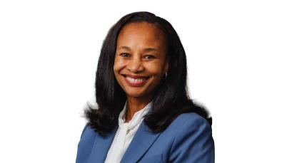  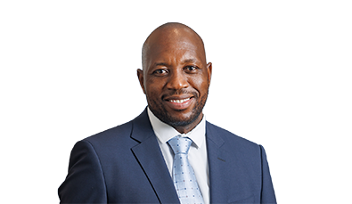  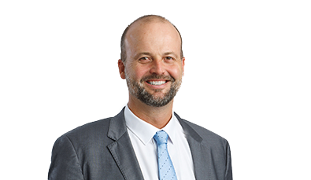  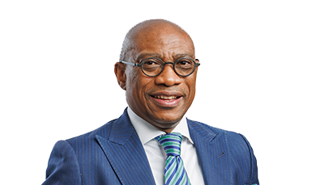 | MURIEL DUBE  Chairman of the Board, Independent Non-Executive Director.  Appointed: 2018 Nationality: South African Education: Msc Environmental Change and Management (Oxford)  Muriel Dube brings a vast amount of experience in environmental policy, sustainability and corporate governance. She previously served as South Africa’s chief climate negotiator under the UNFCCC and held leadership roles at multiple large enterprises such as BHP Billiton, Investec plc and Bidvest Group. She also serves on the board of the UK infrastructure Bank and has held important directorships at Vodacom SA, PG Group and Fluormin plc. She currently chairs the Sasol’s Nomination and Governance Committee and sits on the Capital Investment and Social and Ethics Committees.  SIMON BALOYI  President and Chief Executive Officer, Executive Director  Appointed CEO: 2024 Nationality: South African Education: MSc Chemical Engineering  Simon Baloyi was appointed CEO of Sasol in April 2024. He has been with the company since 2002, holding high leadership roles across Sasol’s core Energy and Chemicals operations. Before he was appointed as CEO, he served as the Executive Vice President of Energy Operations and Technology, he was in charge but not limited to overseeing Sasol’s downstream operations, technology and infrastructure. His jurisdiction also included Secunda, Sasolburg, Ekandustria and the Natref refinery. He currently serves on the Capital Investment Committee and the Safety, Social and Ethics Committee.  WALT BRUNS  Chief Financial Officer, Executive Director  Appointed CFO: 2024 Nationality: South African Education: Bcom CS(SA)  Mr Bruns was appointed Chief Financial Officer and Executive Director of Sasol in September 2024. He has accumulated over 15 years of experience with Sasol, including roles as the CFO of Sasol Southern Africa and CFO of the Global Chemicals Business. Before he moved to Sasol, he worked at Deloitte in both South Africa and the United States. His expertise and knowledge spans the energy and chemicals sectors, and he is a qualified chartered accountant (CA-SA).  VUYO KAHLA  Executive Vice President: Commercial and legal, Executive Director  Appointed: 2019 Nationality: South African Education: BA, LLB  Mr. Kahla has served on Sasol’s Group Executive Committee since 2011 and was given a promotion to the Board in 2019. He is currently the Executive Vice President: Commercial and Legal, and previously held the role of Company Secretary. His impressive career includes executive positions at Transnet and Standard Bank and senior roles within the South African government including Legal Advisor to President Nelson Mandela. He is also the Chairman of the Council of Rhodes University and an alumnus of Cambridge’s sustainability leadership programme. He serves on Sasol’s Safety, Social and Ethics Committee.
Non-Executive Directors
Name | Year Appointed | Role/committees | Key Credentials
STANLEY SUBRAMONEY | 2021 | Audit; Remuneration | CA(SA). Ex-Deputy CEO of PwC Southern Africa. CEO of Menston Holdings. Nedbank board member and Audit Chairperson
MUNUEL CUAMBE | 2016 | Safety, Social and Ethics; Remuneration; Nomination & Governance | Ex-CEO of EDM (Mozambique). Chairman at Standard Bank Mozambique Pension Fund. Energy sector expert with regional board experience
TRIX KENNEALY | 2017 | Chair: Audit; Capital Investment; Nomination and Governance | Former CFO of SARS. Ex-COO at Absa Corporate Bank. Lead Independent Director at Standard Bank. Chaired SA Accounting Standards Board
MARTINA FLOEL | 2018 | Lead Independent; Chair: Capital Investment; RemCo; Social and Ethics; NomGov | Ex-CEO of OXEA Holdings. PhD Chemist with 30+ years in chemical R&D, operations, and supply chain. NED at Synthomer Plc.
KATHY HARPER | 2020 | Audit; Remuneration | Retired CFO of BDP International. Ex-CFO of Tronox and Rio Tinto Diamonds. Board experience in logistics, mining, and ESG oversight.
TIM CUMMING | 2013 | Chair: Remuneration; Social and Ethics | Chair of DRDGOLD and RemCo at Sibanye-Stillwater. Ex-Old Mutual and HSBC. Founder of Scatterlinks; background in mining and financial services.
DAVID G P EYTON | 2024 | Chair: Safety, Social and Ethics; Capital Investment; Audit; NomGov | Former BP executive (1982–2022). Led energy transition, R&D, and digital strategy. Fellow of the Royal Academy of Engineering.

Sasol’s executive remuneration framework is designed to incentivise both short-term performance and long-term value creation, while aligning management interests with those of shareholders. The company offers a balanced mix of short-term incentives (STIs) and long-term incentives (LTIs). STIs are awarded annually in September, subject to approval, and are based on a combination of financial performance metrics, individual performance outcomes, and non-financial KPIs, including safety and environmental targets. The LTI structure for members of the Group Executive Committee (GEC) consists of 70% performance shares and 30% restricted shares. Performance shares vest in two tranches: 50% after three years and the remaining 50% after an additional two years, subject to  Board Remuneration packages  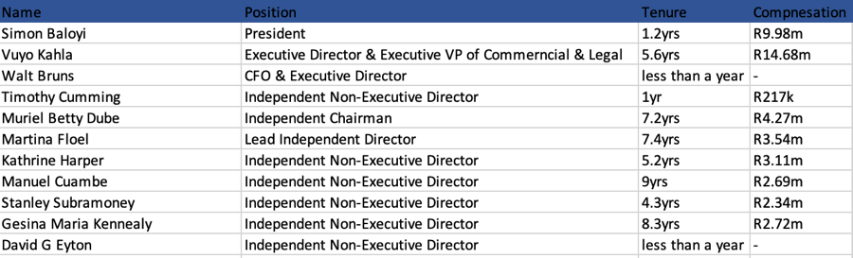  Source:simplywallst | performance outcomes. Restricted shares vest fully after five years. Dividend equivalents are awarded on LTIs based on the vesting percentage at each vesting date. For other participants, vesting periods vary between three and five years, depending on seniority and award type. To further promote alignment with shareholder interests, Sasol enforces a Minimum Shareholding Requirement (MSR), whereby the President and CEO must hold shares equal to 300% of annual pensionable remuneration, the CFO 200%, and other executive directors and prescribed officers 100%. Vested LTIs must be retained (after tax) until these thresholds are met. Additionally, a post-cessation shareholding requirement of 18 months applies, ensuring continued alignment even after executives exit their roles. Overall, Sasol’s incentive framework reflects a considered and increasingly ESG-integrated approach, with appropriate deferral and retention mechanisms to mitigate excessive risk-taking and promote sustained corporate performance
  - Environmental, Social and Governance (ESG)
The company’s ESG main agenda is its transformation plan that they like to call “Future Sasol” this project focuses on sustainability, decarbonisation and shared value creation. Taking focus on the environmental side of the project, Sasol has committed and is working towards a 30% reduction in their Scope 1 and 2 greenhouse emissions. The goal is to have achieved this reduction by 2030 and is averaging a decrease of 5% in emissions every year. In pursuit of a reduction in emissions the Msenge Wind Farm project (69 MW) was completed in October 2024 and is now commercially operating, the aim for this farm is that it can create 1200 MW of renewable energy capacity by 2030. | THE FUTURE SASOL  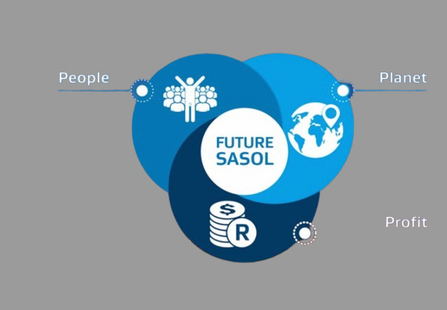

Sasol has not neglected its social responsibilities as it has contributed generously to the communities in which it operates in. A analysis on the 2024 financial statements shows that the company has invested R693.2 million in global socio-economic development initiatives that focus on education, health infrastructure and economic inclusion. The Company has also distributed more than 2700 bursaries to students from low income households as well as providing skill development centres to underdeveloped regions.

Corporate Governance focuses on how well a company is run in the sense that is the company run ethically, accountability and transparency. Sasol follows the King IV principles and has a strong independent and diverse board. The board has introduced dedicated committees focused on risk, sustainability , ethics and the capital investment of investors. The company has a strict Code of Conduct, Minimum Shareholding Requirements and shareholder policies. These governance tools promote accountability and transparency in the company that allows for the shareholders, environment and communities interests to be maximised.

